NORTHERN PACIFIC REGIONAL TOURNAMENT
OGREN PARK ALLEGIANCE FIELD
MISSOULA, MONTANA
MAY 9-11, 2014

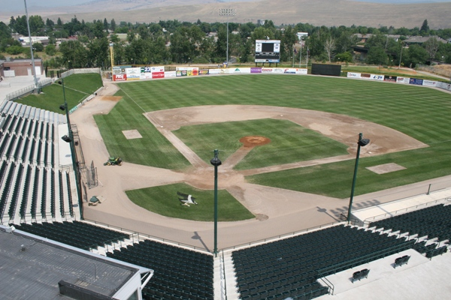

After calling La Grande, Oregon home for 7 years a decision was made to try and increase the attendance for the participating teams. The NoPac Regional Tournament will be moving to a new location this year in beautiful Missoula, Montana.
Ogren Park Allegiance Field will play host to the 3-day tournament being held May 9-11 for the Champions of the North, South, West Conferences and an At-Large Bid.

Tournament Schedule
May 9
12:00 P.M. University of Montana vs Utah State University
3:30 P. M. Eastern Washington University vs University of Oregon
May 10
11:00 A.M. Winner GM1 vs Winner GM2
2:30 P.M. Loser GM1 vs Loser GM2 (Loser Eliminated)
6:00 P.M. Loser GM3 vs Winner GM4 (Loser Eliminated)
May 11
11:00 A.M. Winner GM3 vs Winner GM5
2:30 P.M. If Necessary

#1 Seed Utah State University Aggies – South Conference Champion
#2 Seed University of Oregon Ducks – Western Conference Champion
#3 Seed Eastern Washington University Eagles – Northern Conference Champion
#4 Seed University of Montana Grizzlies – At Large Bid

Higher seed will be the home team throughout the tournament.

